**Points Discussed with Team IT(Keshav sir):**

* Uploading of file showing error option for all the attachment points. (Repeated concern)



* Remove option also required for all attachment points(Quality plan, DFMEA).



* Export file design development plan is not displaying responsible and approval authority filled in PPR portal.

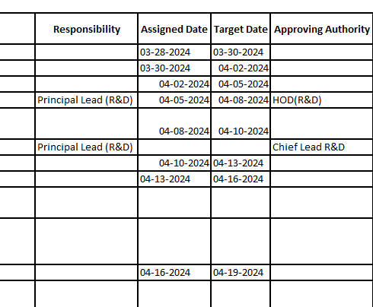

* In export file -Hierarchy of process step is not same as ppr portal.

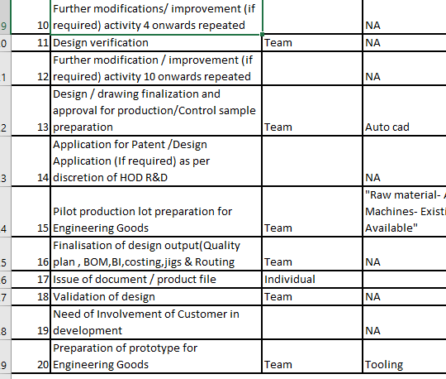

* Opening of uploaded File showing error status -solved on 28.05.24



* (_ ) required wherever data has not been entered/selected or NA has been mentioned..

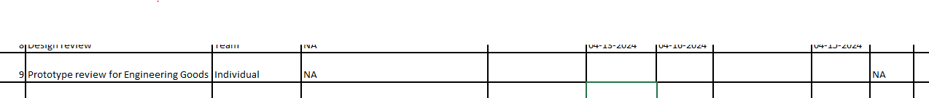

* UOM of Static and dynamic strength unit converts after re-opening the saved data in portal-(Repeated concern).

**Design input data sheet**

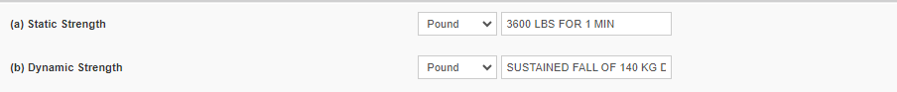

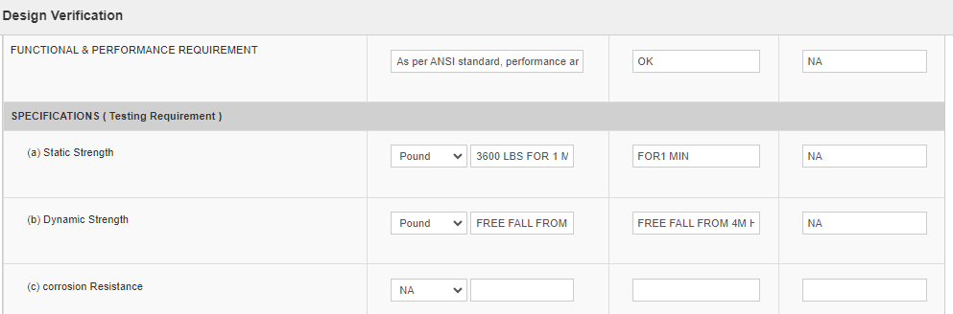

* Job sheet portal link required with PPR portal

